**Project analyst Annual Sales Performance Report 2019**

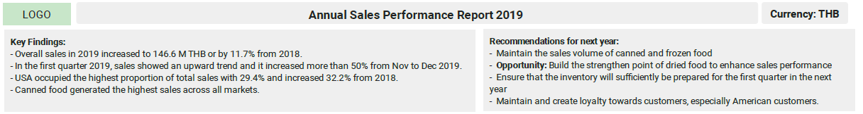

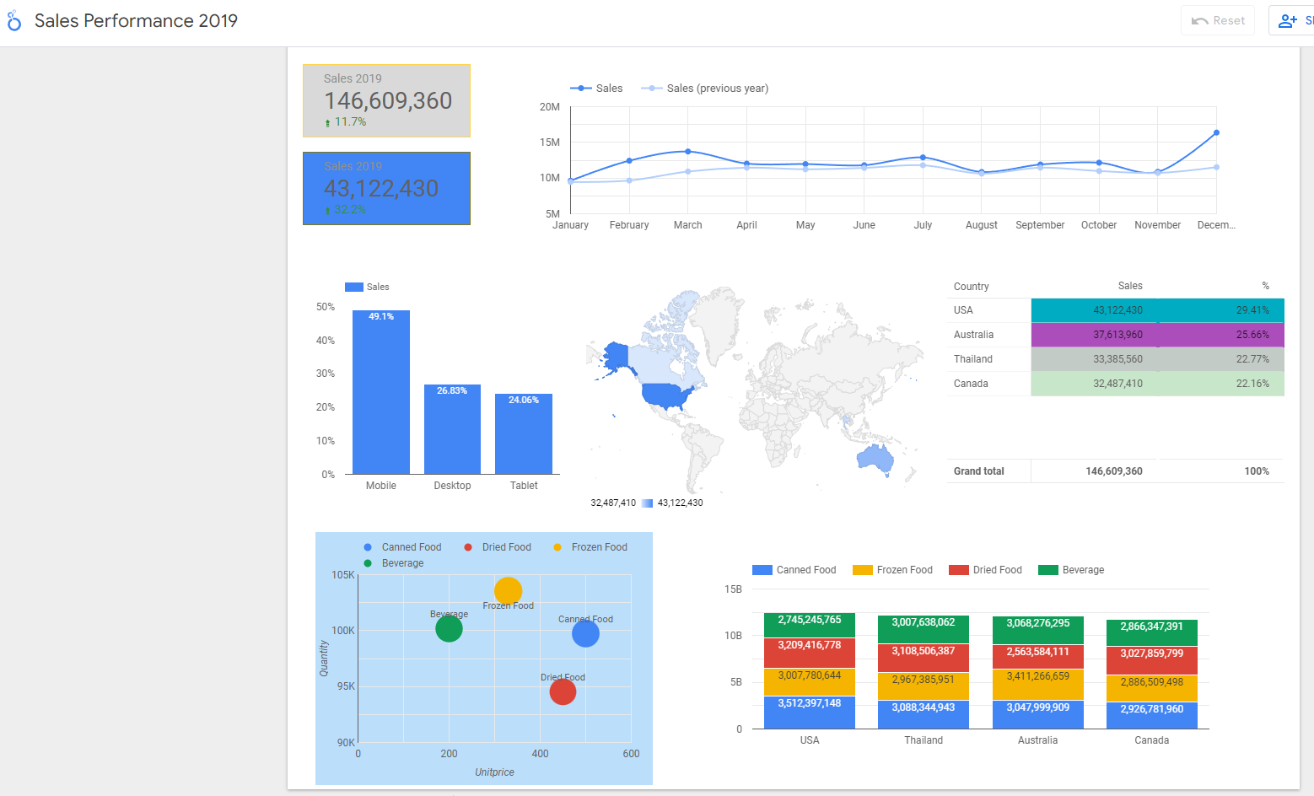

<https://lookerstudio.google.com/s/vmYpa_xn_2Y>